Stage 1 – Crazy Train
COURSE DESIGNER: DelMarVa 2026 Design Team

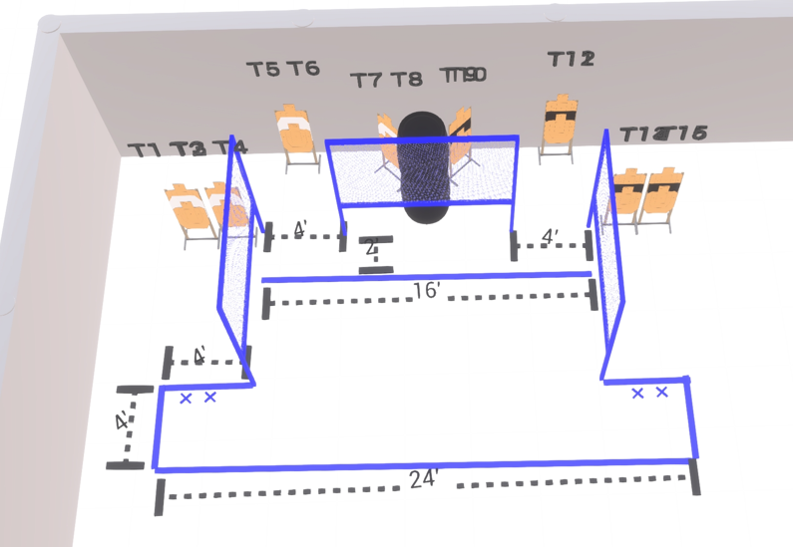

Written Stage Briefing:

Stage 1 – Crazy Train - is a 32 round, 160 point, Comstock Course. There are 16 cardboard targets.

Starting with Both feet touching the Shooting Sports Innovations Xs.
Handgun is loaded and holstered, wrists below belt.
PCC is loaded held in both hands, stock on belt.

On the audible start signal, engage targets from within the shooting area.

USPSA / NROI Range Commands:
- Make Ready
- Are you ready?
- Standby
- If finished, unload and show clear
- If clear, hammer down and holster (Handgun)
If clear, hammer down and flag (PCC)
If clear, cylinder closed and holster (Revolver)
- Range is clear

Setup Notes:
6 Single Wall Stands
3 Full Walls
1 Half Wall
8 Target stands / 16 target sticks
2 Starting Xs
4+ Barrels



